

0 out of 1 activities on this page have been completed.

Cohort ENG-123-Q1729-OL-TRAD-UG.18EW1

Activity: Creating Keywords (GRADED)

NOTE: This activity will be graded based on completion.

Remember your writing notes? Let's use them to think of some keywords that can help you when it comes time to do your research! Using the guided activity below, come up with a list of potential keywords to use while conducting research for the persuasive essay. Review the examples provided to make sure you're on the best route, and if you'd like to talk to a librarian about your choices,
You will use your work in this section to help you with the Opposing Viewpoints activity coming up in 2-6.

Mind Mapping

Mind mapping is a useful visual technique for brainstorming keywords. The brain is constantly making connections between different aspects of a problem. By capturing these connections and exploring them systematically, we are less likely to miss possible solutions. Mind mapping is also a highly visual and efficient way of organizing ideas.

To begin mind mapping, the main subject/research topic is written in the center of a sheet in a circle. New ideas are drawn in the form of spokes branching from this central idea. These ideas are likely to lead to further ideas which form new spokes and so on. It can be helpful
to use different colors for different branches of the map. By the end of the mind mapping process, you will have an entire page full of keywords related to your research topic.

The first step in creating your own mind map is to grab a blank piece of paper and a pen or pencil (several different colored pens would be ideal). In the middle of the page, write down the main subject that you plan to research for the persuasive essay project. Then draw a circle around it:

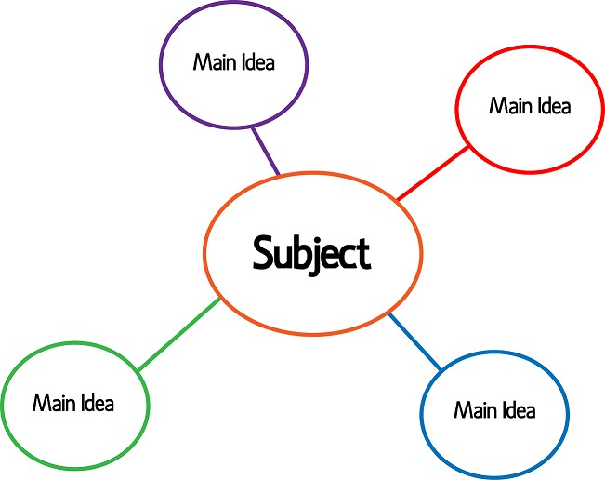
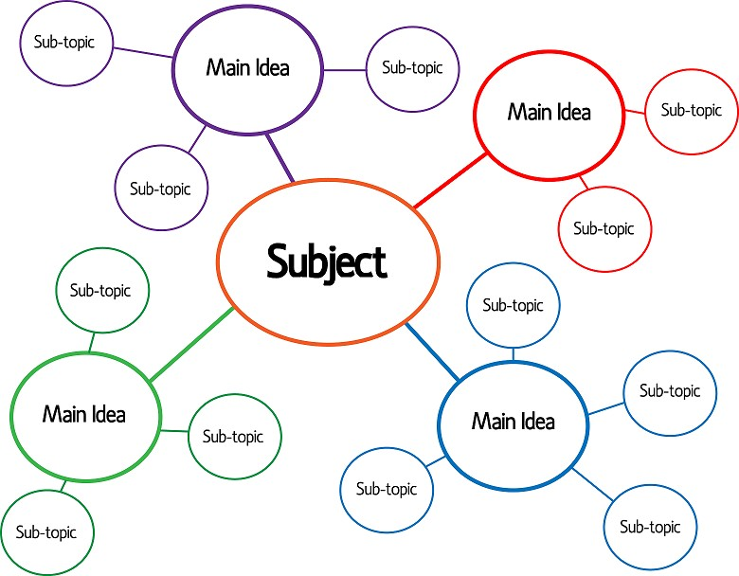
From the main circle, draw lines outward to represent the main ideas:

As you dig into each of the main ideas, add sub-topics and supporting evidence:

We can take the mind map as far as it needs to go to cover all our main ideas, our sub- topics, and our relevant evidence.

After your mind map is complete, look over the results and pick out the most interesting terms that you have generated on the page—these terms are your keywords.

Sample Mind Map

The image below depicts a sample mind map drawn out based on the research topic "the impact of technology on urban education."

You have not yet completed the activity below.

After you have drawn out your mind map, make a list of your main topic, sub-topics, and supporting evidence in the textbox below and then click "Submit." Your response will be
saved to your Notebook, accessible through the "Course Tools" menu.

Main topic: Sub-topics:

Supporting Evidence:

